@ca.worldsign.org

# vim /etc/dovecot/conf.d/15-mailboxes.conf

각 메일박스 설정에 auto = subscribe 추가.

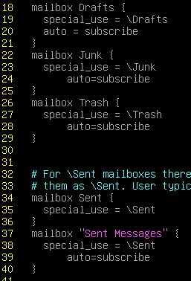

# systemctl restart dovecot.service